Alex is attending a Halloween party with his girlfriend Silvia. At the party, Silvia spots a giant chocolate bar. If the chocolate can be served as only 1 x 1 sized pieces and Alex can cut the chocolate bar exactly K times, what is the maximum number of chocolate pieces Alex can cut and give Silvia?
Input Format
The first line contains an integer T, the number of test cases. T lines follow.
Each line contains an integer K
Output Format
T lines. Each line contains an integer that denotes the maximum number of pieces that can be obtained for each test case.
Constraints
1<=T<=10
2<=K<=10⁷
Note
Chocolate must be served in size of 1 x 1 size pieces.
Alex can't relocate any of the pieces, nor can he place any piece on top of other.
Sample Input #00
4
5
6
7
8
Sample Output #00
6
9
12
16
Explanation
The explanation below is for the first two test-cases. The rest of them follow a similar logic.
For the first test-case where K = 5,You need 3 Horizontal and 2 vertical cuts.
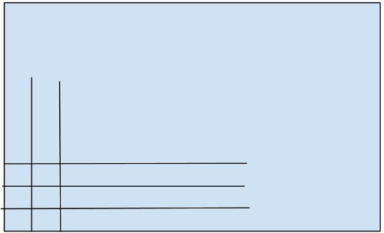For the second test-case where K = 6,You need 3 Horizontal and 3 vertical cuts.

